BASICS IN C PROGRAMMING

**Q10 Write a program to find the biggest element in 2D array.**

**Code:**

#include <stdio.h>

int main()

{

int r,c,a[50][50],big=0;

printf("Enter the number of cols");

scanf("%d",&c);

printf("Enter the number of rows");

scanf("%d",&r);

printf("Enter the numbers");

for(int i=0;i<r;i++)

{

for(int j=0;j<c;j++)

{

scanf("%d",&a[i][j]);

if(a[i][j]>big)

{

big=a[i][j];

}

}

}

printf("Largest number is %d",big);

return 0;

}

**Output:**

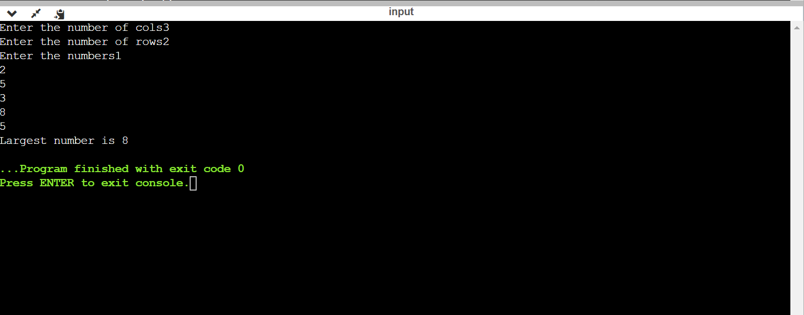

**Q11 Find the sum of numbers from 5+4+3+2+1 using recursion.**

**Code:**

#include <stdio.h>

int recsum(int n)

{

if(n==1)

return(n);

else

return(n+recsum(n-1));

}

int main()

{

int s;

s=recsum(5);

printf("Sum = %d",s);

return 0;

}

**Output:**

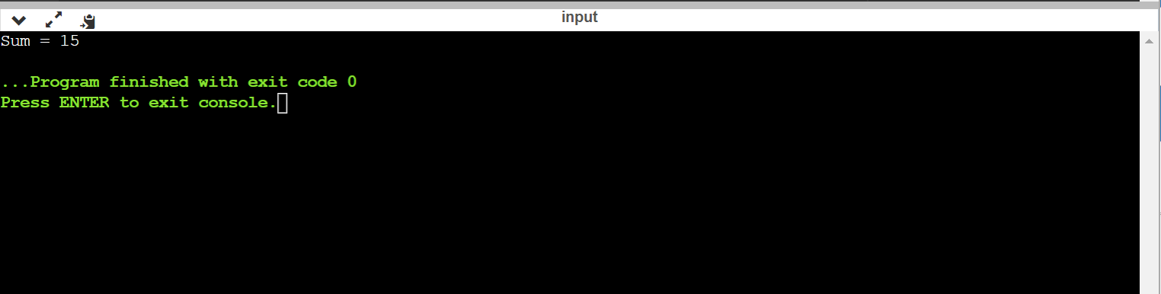

**Q12 Using pointer to array find the smallest number in the array.**

**Code:**

#include <stdio.h>

int main()

{

int a[100],n,*ptr,small;

ptr=&a[0];

printf("enter the number of elements");

scanf("%d",&n);

printf("Enter the elements");

for(int i=0;i<n;i++)

{

scanf("%d",&a[i]);

}

small=a[0];

for(int i=0;i<n;i++)

{

if(small>*ptr)

{

small=*ptr;

ptr++;

}

}

printf("Smallest = %d",small);

return 0;

}

**Output:**

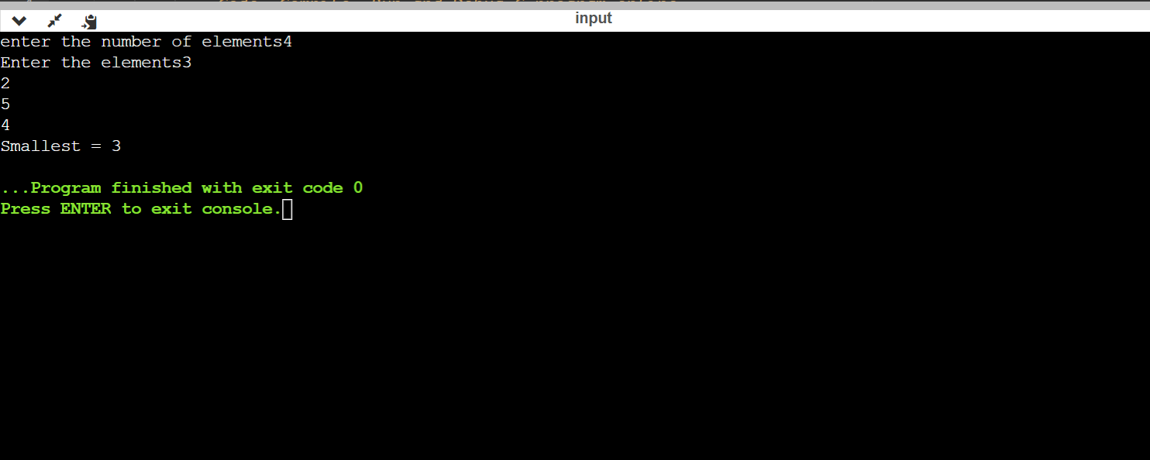

**Q13 Find the sum two 1D array.**

**Code:**

#include <stdio.h>

int main()

{

int a[100],b[100],c[100],n,m;

printf("enter the limit of arrays");

scanf("%d",&n);

printf("Enter the elements of first array");

for(int i=0;i<n;i++)

{

scanf("%d",&a[i]);

}

printf("Enter the elements of second array");

for(int i=0;i<n;i++)

{

scanf("%d",&b[i]);

}

for(int j=0;j<n;j++)

{

c[j]=a[j]+b[j];

}

printf("Sum of the two arrays are");

for(int j=0;j<n;j++)

{

printf("%d \n",c[j]);

}

return 0;

}

**Output:**

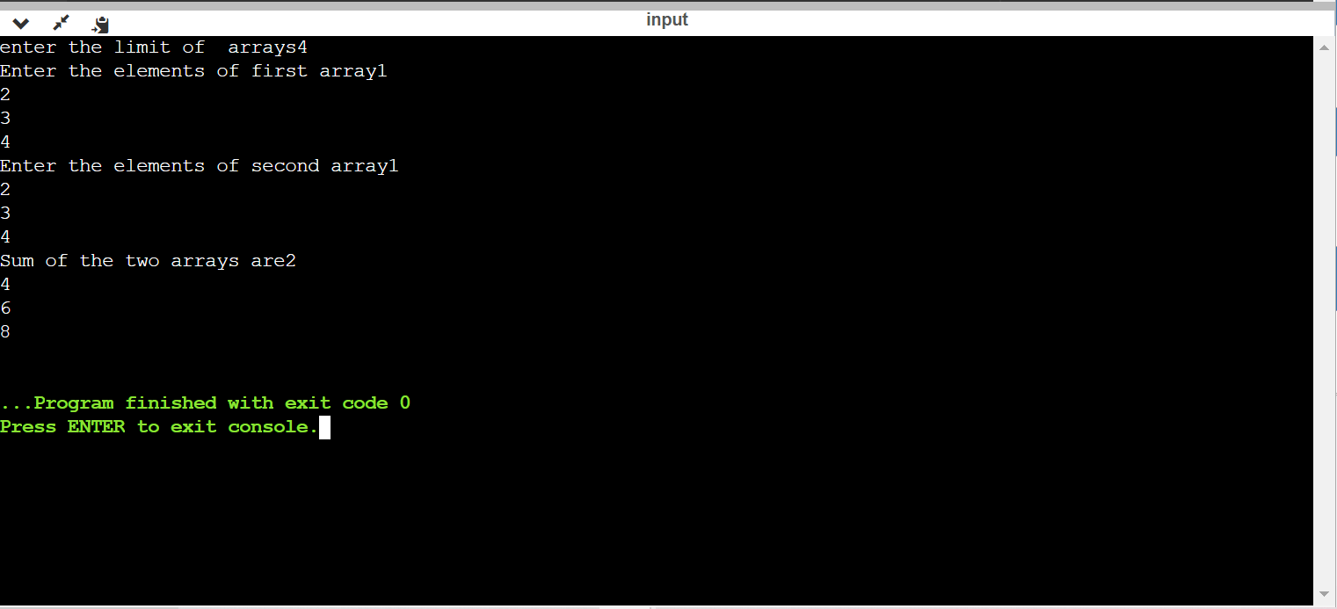

**Q13 Display the transpose of 3*3 matrix.**

**Code:**

#include <stdio.h>

int main()

{

int a[10][10],t[10][10];

printf("Enter the elements in the array");

for(int i=0;i<3;i++)

{

for(int j=0;j<3;j++)

{

scanf("%d",&a[i][j]);

}

}

printf("Elements of the array is \n");

for(int i=0;i<3;i++)

{

for(int j=0;j<3;j++)

{

printf("%d",a[i][j]);

}

printf("\n");

}

for(int i=0;i<3;i++)

{

for(int j=0;j<3;j++)

{

t[i][j]=a[j][i];

}

}

printf("Transpose matrix is\n");

for(int i=0;i<3;i++)

{

for(int j=0;j<3;j++)

{

printf("%d",t[i][j]);

}

printf("\n");

}

return 0;

}

**Output:**

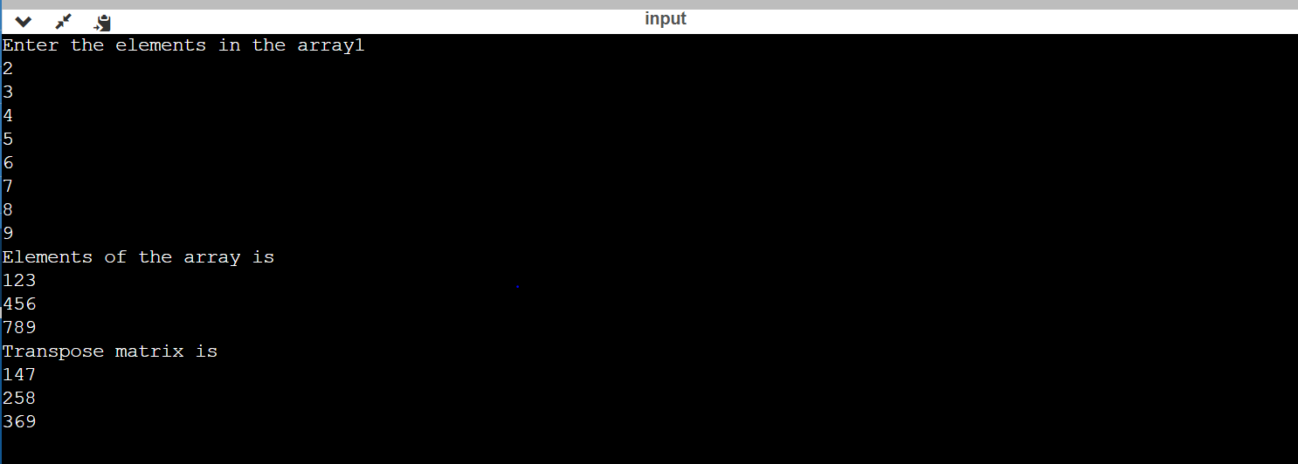

**Q14 Create 3 node with 2 data part,find the sum of data1 of 3 node.**

**Code:**

#include <stdio.h>

struct node

{

int data1,data2;

struct node*ptr;

};

int main()

{

struct node obj1,obj2,obj3;

int sum;

obj1.data1=20;

obj1.data2=30;

obj2.data1=40;

obj2.data2=70;

obj3.data1=10;

obj3.data2=80;

obj1.ptr=&obj2;

obj2.ptr=&obj3;

obj3.ptr=NULL;

sum=obj1.data1+obj2.data1+obj3.data1;

printf("Sum= %d\n",sum);

return 0;

}

**Output:**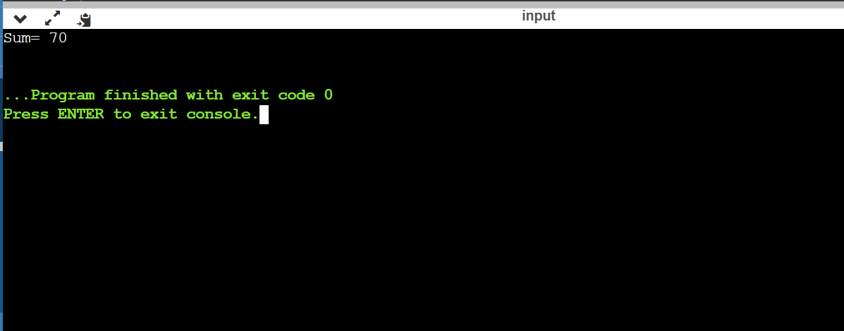

**Q15 Create structure with id ,name,salary,DA,TA,HRA, accept value for all from user.Calculate GP=salary+(DA+TA+HRA)/3 for employees [using array of structures].Using pointer to array find sum of all GP.**

**Code:**

#include <stdio.h>

struct emp

{

int id;

char name[50];

float salary,DA,TA,HRA;

};

int main()

{

int n;

float GP[100],*ptr;

struct emp e[100];

printf("Enter number of employees");

scanf("%d",&n);

for(int i=0;i<n;i++)

{

printf("enter id\n");

scanf("%d",&e[i].id);

printf("enter name\n");

scanf("%s",e[i].name);

printf("enter salary\n");

scanf("%f",&e[i].salary);

printf("enter DA\n");

scanf("%f",&e[i].DA);

printf("enter TA\n");

scanf("%f",&e[i].TA);

printf("enter HRA\n");

scanf("%f",&e[i].HRA);

GP[i]=e[i].salary+(e[i].DA+e[i].TA+e[i].HRA)/3;

}

ptr=&GP[0];

int sum=0;

for(int i=0;i<100;i++)

{

sum=sum+*ptr;

ptr++;

}

printf("Sum of GP= %d\n",sum);

return 0;

}

**Output:**

